Client Jobs:
Server:
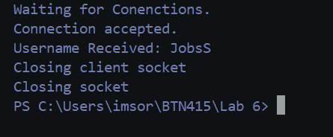
Client:
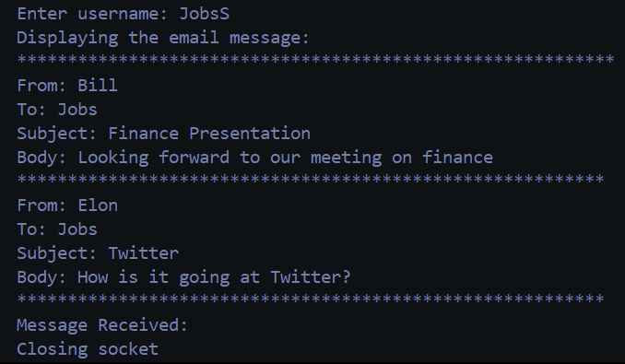
—---------------------------------------------------------------------------------------------------
Mail that doesn’t exist:
Server:
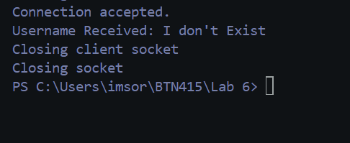
Client:
